**Assignment Submission Document Chapter 4**

**Paste a screenshot of your form in the IDE below (Program not running):**

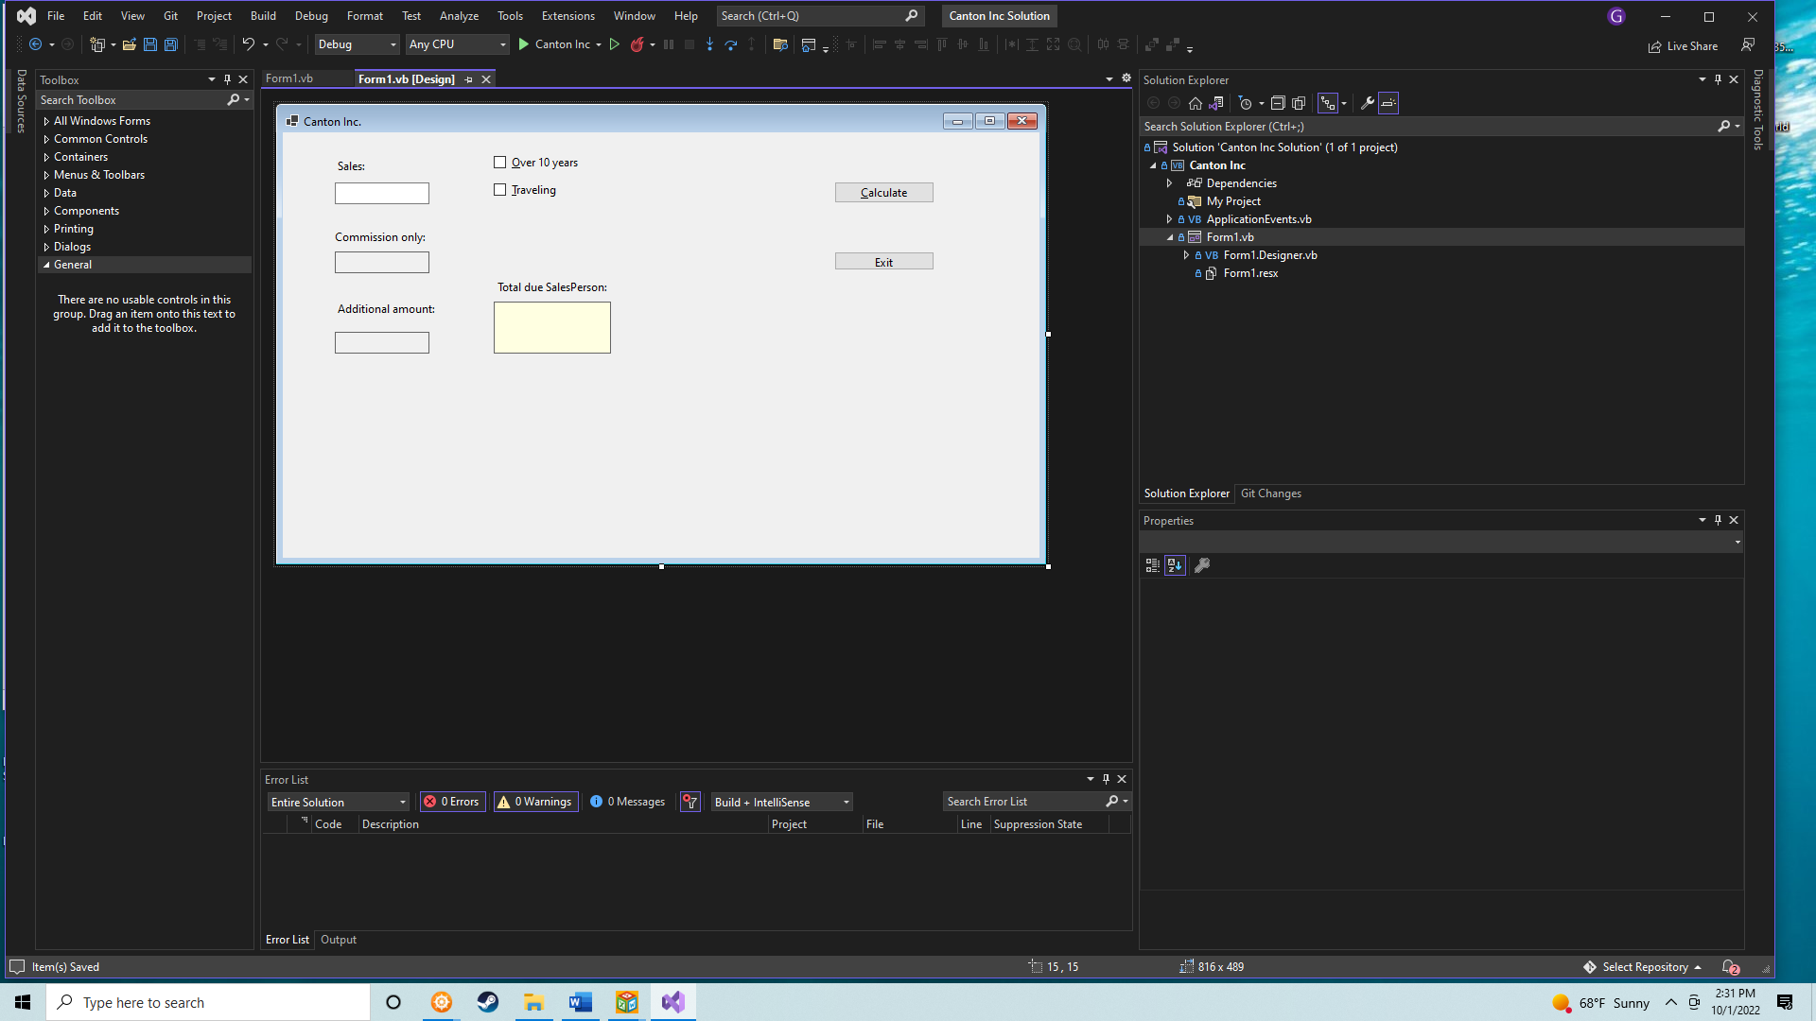

**Paste your program code below:**

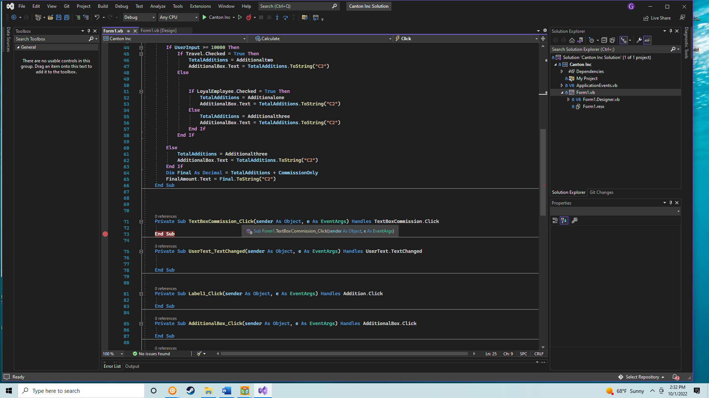

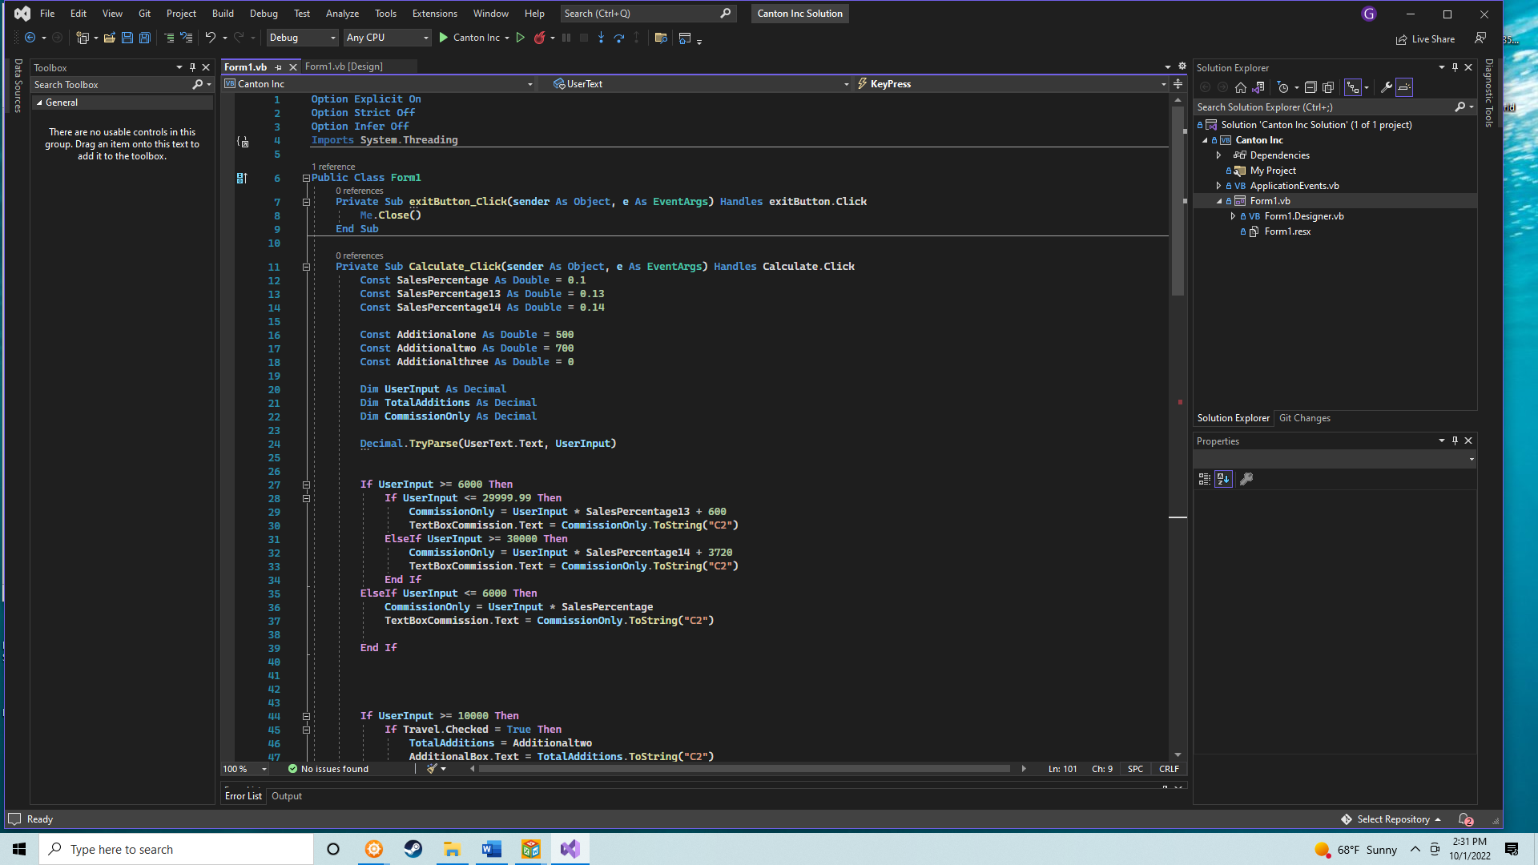

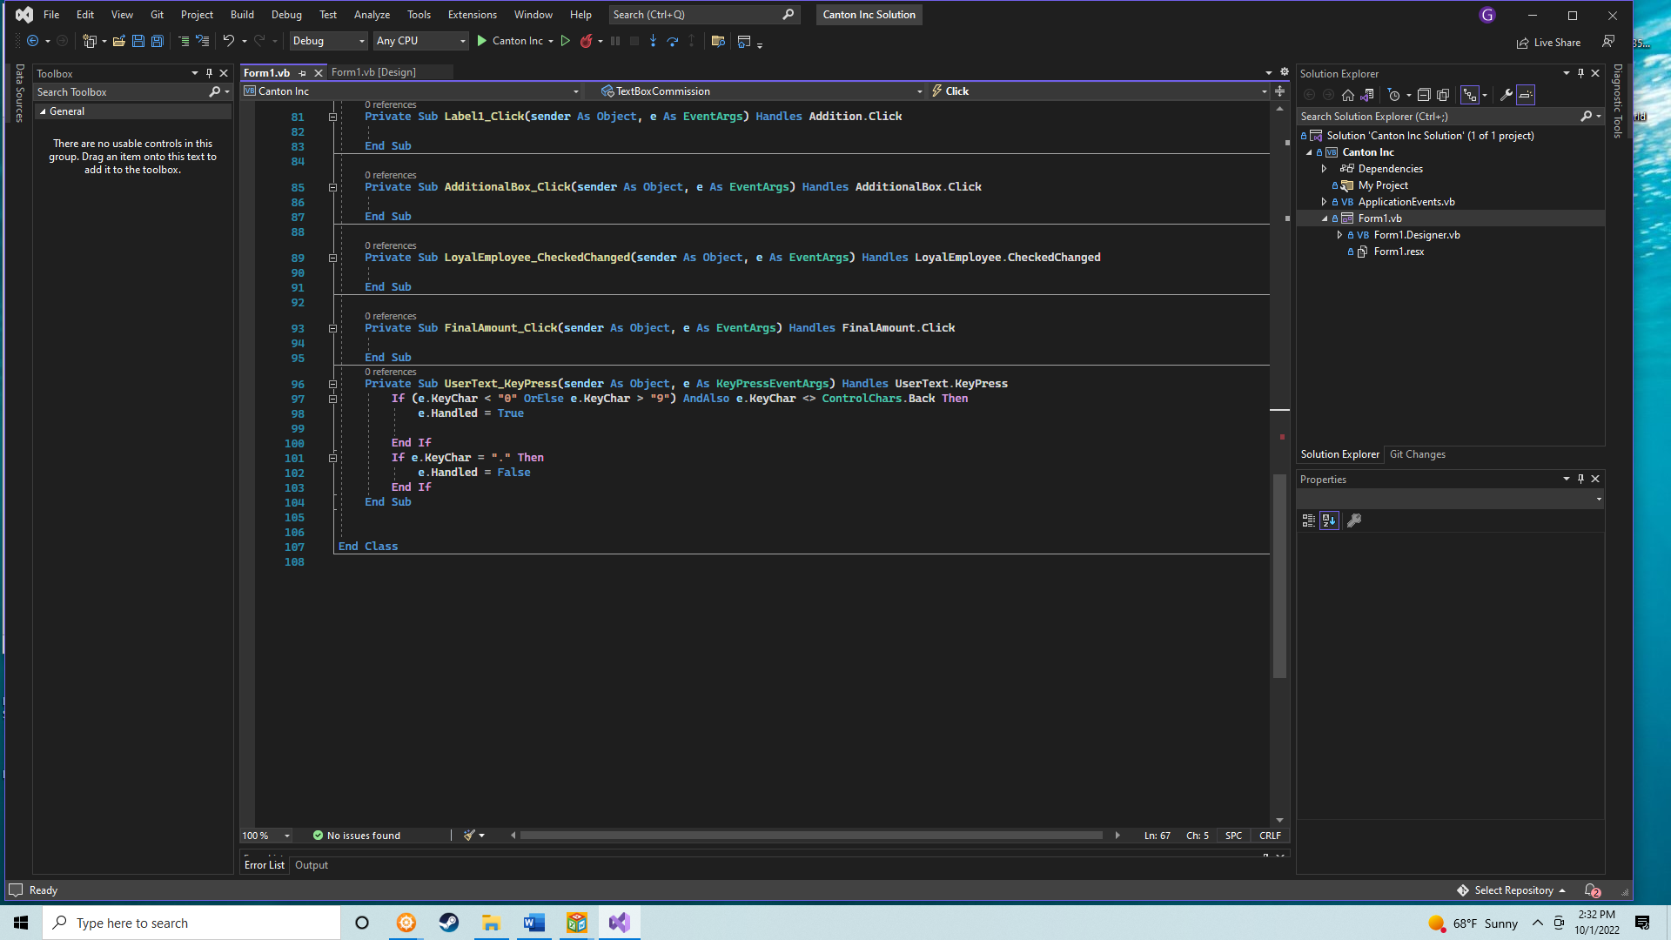**Paste 3 screenshot of your program running with the following data for each screenshot:**

1. **Sales = 1000, Over 10 years is checked.**

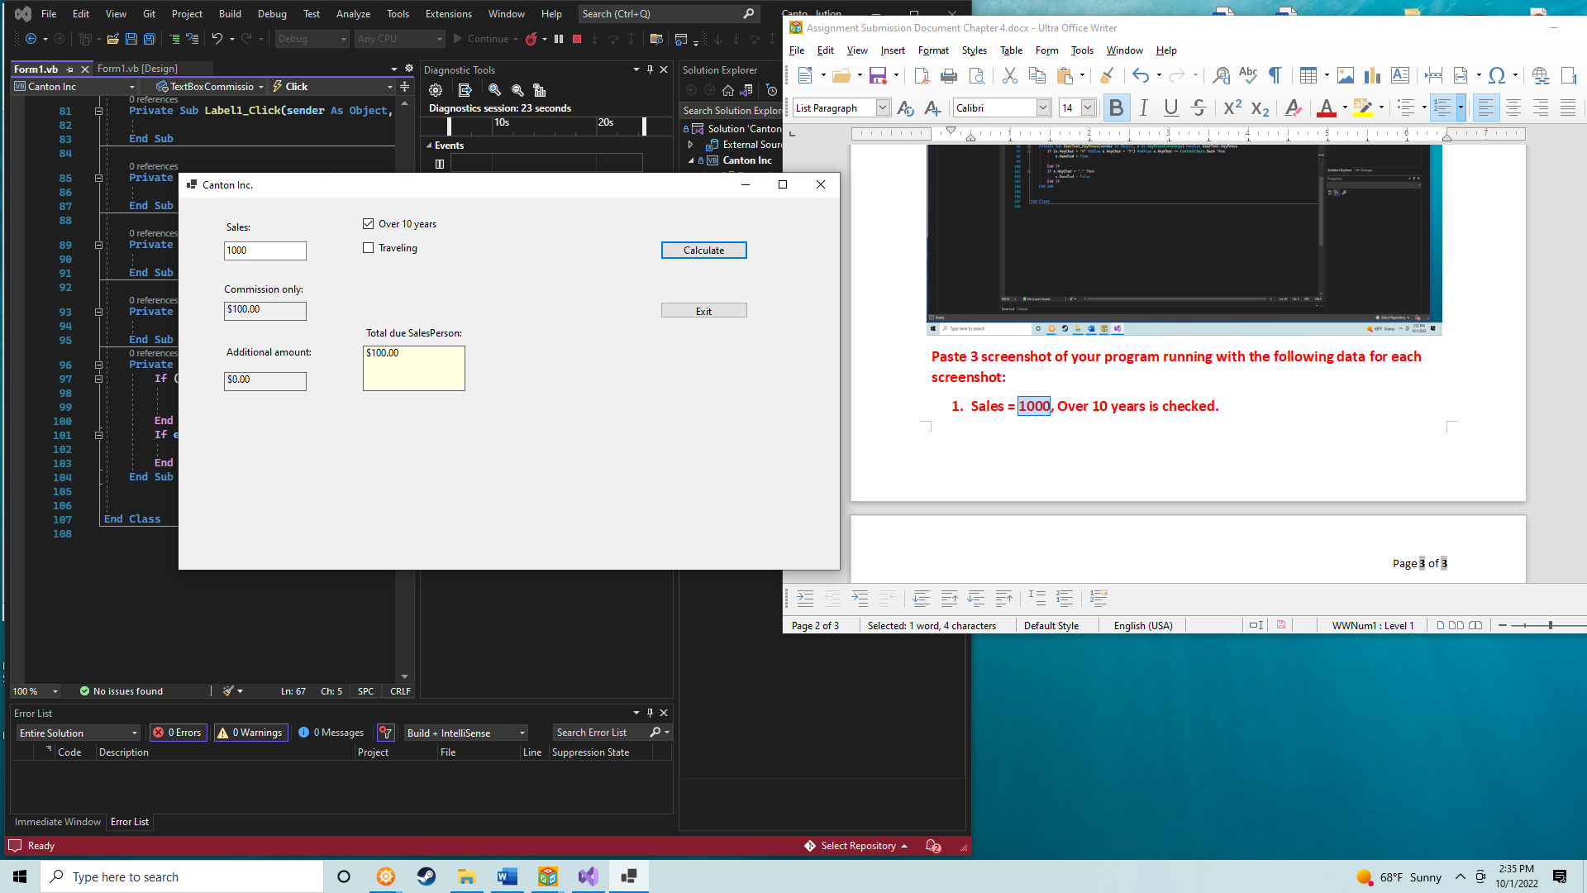

1. **Sales = 10000, Over 10 years and Traveling are checked.**

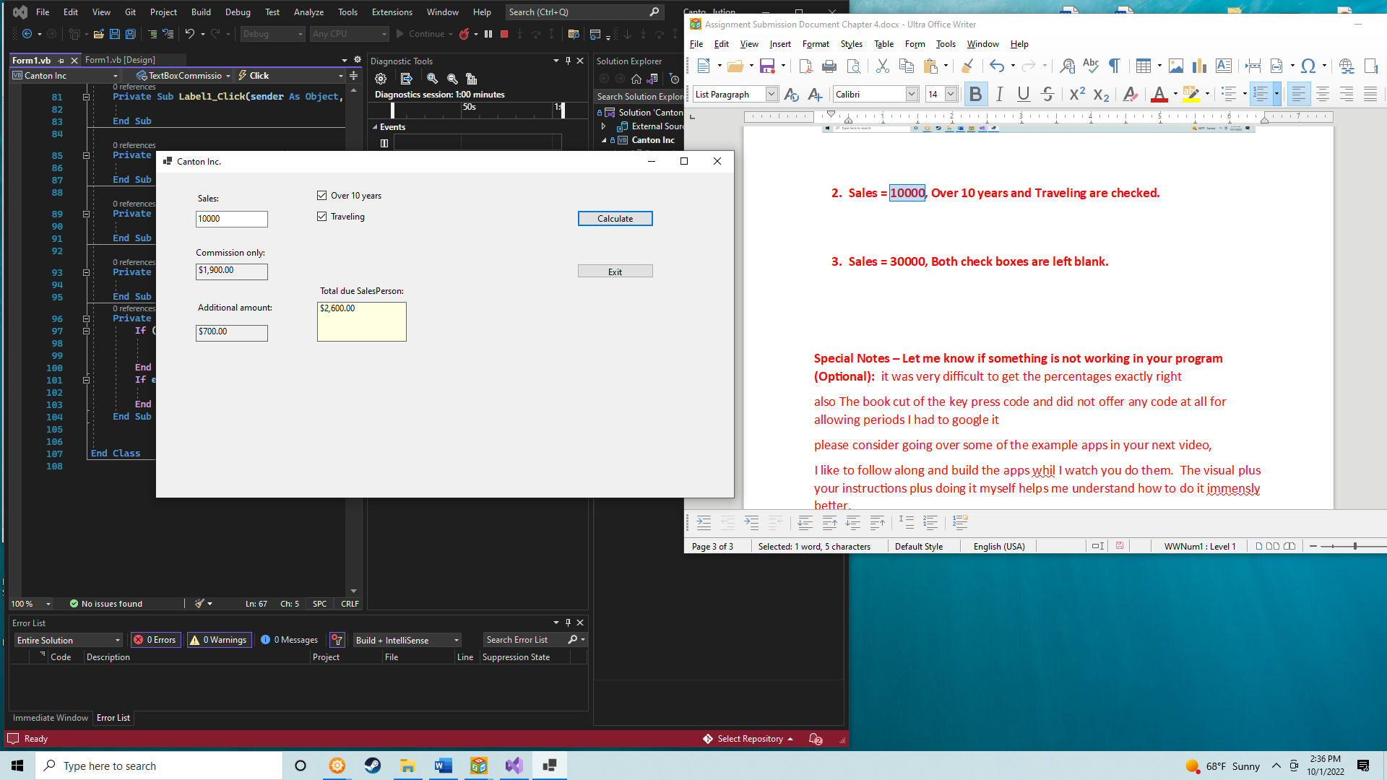

1. **Sales = 30000, Both check boxes are left blank.**

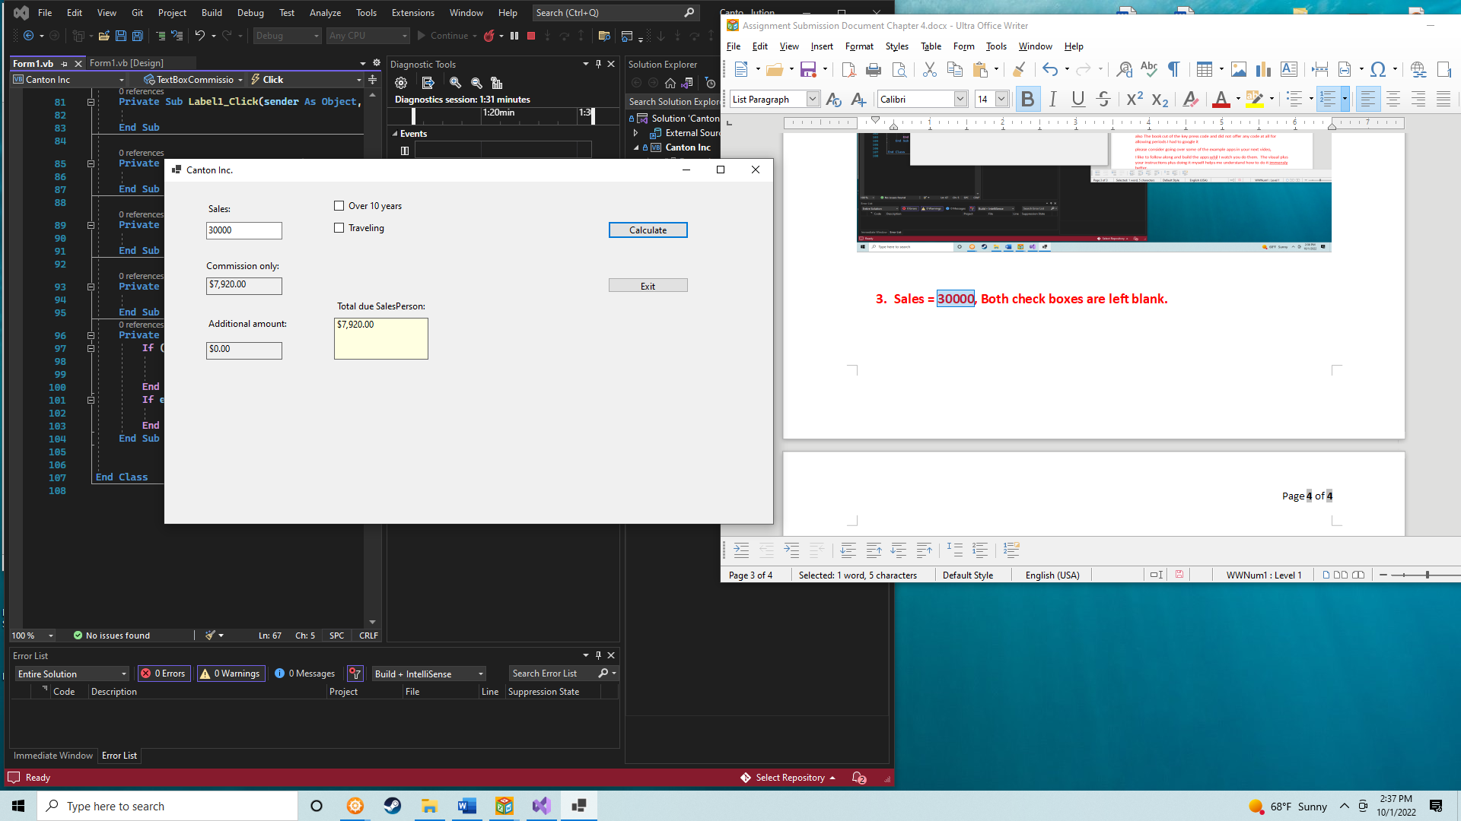

**Special Notes – Let me know if something is not working in your program (Optional):** it was very difficult to get the percentages exactly right

also The book cut of the key press code and did not offer any code at all for allowing periods I had to google it

please consider going over some of the example apps in your next video,

I like to follow along and build the apps while I watch you do them. The visual plus your instructions plus doing it myself helps me understand how to do it immensly better than if I just read the book.